**PRESS RELEASE**

**FOR IMMEDIATE RELEASE** **CONTACT:**

Dr. Griffan Randall, D.O., PLLC

518-655-1590

doctor@drgriffanrandall.com

Dr. Randall Expands Practice To Provide Patients Advanced Mental Health Care with Transcranial Magnetic Stimulation (TMS) Therapy

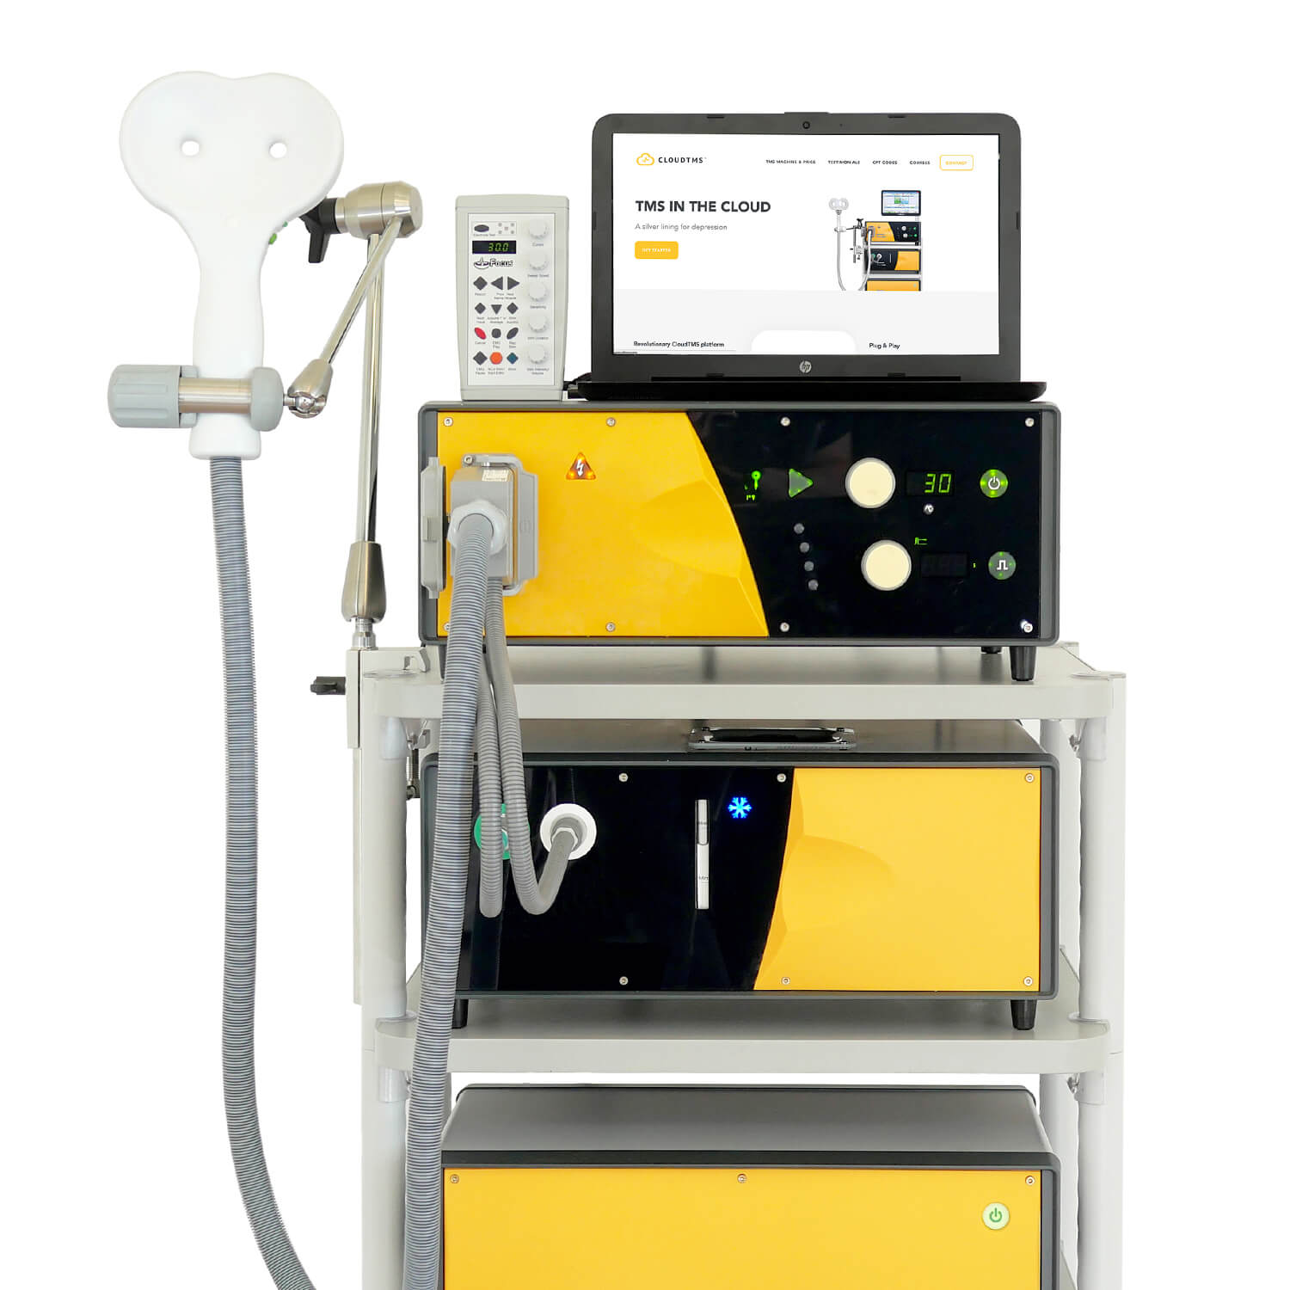LATHAM, NY, November 1st, 2024 – As of today, Dr. Griffan Randall now offers Transcranial Magnetic Stimulation (TMS) therapy in collaboration with Clearwave TMS. This non-invasive treatment, which uses magnetic fields to stimulate specific areas of the brain, will be available at 3 Lear Jet Lane, Suite 203S, Latham, NY.

TMS therapy has shown promising results in treating depression and other mental health conditions, offering hope to patients who have not responded well to traditional treatments.

Dr. Randall's decision to offer TMS therapy as an independent contractor with Clearwave TMS reflects her commitment to providing cutting-edge, evidence-based treatments to her patients. "I'm excited to help bring this innovative therapy to the Capital District," said Dr. Randall. "TMS offers a new avenue of treatment for those struggling with depression, potentially improving their quality of life significantly."

TMS therapy is FDA-approved for treating major depressive disorder and has been gaining recognition for its effectiveness and minimal side effects compared to other treatments. The procedure is typically performed in an outpatient setting and does not require anesthesia, allowing patients to resume their daily activities immediately after each session.

Patients interested in learning more about TMS therapy or scheduling an appointment with Dr. Randall can visit her website at www.drgriffanrandall.com or call Clearwave TMS office at (845)-712-9352.

**About Dr. Griffan Randall:**

****Dr. Randall specializes in Psychiatry for Adolescents through Geriatrics. She is Board Certified by the American Board of Psychiatry and Neurology and offers not only medication management therapy, but also various individual therapies, group therapies. With the addition of TMS therapy to her practice, she continues to expand her range of treatments to address the diverse needs of individuals struggling with mental health issues.

She is currently accepting new patients. Her office is located at 11809 Western Avenue, Albany, NY 12203. Phone number: 518-655-1590, Website: www.drgriffanrandall.com

“Diagnoses are not labels, but rather guides to individual treatment. And although there are only a finite number of diagnoses in the medical lexicon, there are an infinite number of human experiences. Those experiences are unique to each individual. I believe that as unique as each person’s experience has been, so, too, should their treatment plan be.” ~ Dr. Griffan Randall

# # #

If you would like more information about this topic, please call Dr. Griffan Randall at 518-655-1590 or email: doctor@drgriffanrandall.com. A copy of this press release and original photos can be seen and downloaded from: <https://www.drgriffanrandall.com/press-releases/2024/11/01/milestones/dr-randall-provides-transcranial-magnetic-stimulation-tms-therapy>